http://www.amnesty.ca/take_action/actions/nigeria_forced_evictions.php

Nigeria: forced evictions in Lagos State
Posted: 24 January 2006
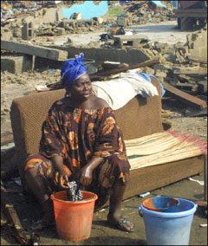
A displaced female resident of Makoko washes her clothes in front of her demolished home, 6 May 2005, in Makoko. Dozens of people were rendered homeless and property destroyed as agency of the Lagos state government demolished shanty structures and worship centres in Makoko district of Lagos.
PIUS UTOMI EKPEI/AFP/Getty Images
“My baby boy is four days old. I delivered him here after my house had been demolished. Only my mother was here to help me, and the boy has not seen a doctor or nurse yet. My husband [has] run away after the bulldozers came in on Thursday. Now I spend the nights in the class rooms in the school with many other families. I have no money.” Miriam Usman, 30, who gave birth in the demolition site of Makoko in Lagos in late April 2005
Hundreds of Nigerians are still sleeping out in the open nearly nine months after bulldozers and armed police arrived in their community to demolish homes, churches, a mosque and a medical clinic.
During three days at the end of April 2005, approximately 3,000 residents of the community of Makoko in Lagos, Nigeria’s commercial capital, were forcibly evicted from their houses. Those evicted claimed that they had neither been given prior notice nor consulted on the planned evictions. Some of them, including children, were beaten up by law enforcement officials and suffered injuries as a result of the force used. Others had all their belongings and houses destroyed by the demolition forces.
These evictions were carried out in order to execute a court judgement dating from 2000, which granted ownership of the area to a private landowner. The Nigerian authorities have failed to provide assistance to those who were unable to find adequate alternative housing and many were deprived of schooling or means of earning a living.
The Makoko evictions are far from an isolated incident. In the last five years it is estimated that over 1,200,000 people, 23,300 households and 30 squatter settlements have been forcibly evicted in different parts of Nigeria, according to the Centre for Housing Rights and Evictions (COHRE), a Geneva-based international non-governmental organization.
Amnesty International is concerned that the practice of forced eviction – specifically prohibited under international human rights treaties to which Nigeria is a party – has affected mainly marginalized communities, people who have been left to live for years without adequate access to amenities such as clean water and sanitation or adequate social services.

